ELE725 Lab 1 Report

Sampling and Quantization (Audio)

Bethany Santos

line 1 (of *Affiliation*): dept. name of organization

line 2: name of organization, acronyms acceptable

Toronto, Canada

Authors Name/s per 2nd Affiliation *(Author)*

line 1 (of *Affiliation*): dept. name of organization

line 2: name of organization, acronyms acceptable

line 3: City, Country

line 4: e-mail address if desired

*Abstract*— The abstract is usually a short summary of what was attempted in this lab, and a brief statement of the outcome(s). This should be no longer than 150 words in length. The abstract should be a single paragraph (not multiple). The Keywords line following the abstract is where you would include a set of no more than 5 key topics/words that describe key concepts addressed in the report.

Keywords-component; formatting; style; styling; insert (key words relating to the topics discussed in this lab report)

# Introduction/Theory *(Heading 1)*

Sampling and Quantization is a fundamental practice when it comes to digital multimedia signal processing. The purpose of this lab is to investigate the effects of up sampling, down sampling, uniform quantization and non-uniform quantization using mu-law to an audio signal.

# Theory

## Sampling

An analog signal can be broken down to discrete values through sampling. Periodical sampling of a continuous time signal $x_{a}(t)$ can be mathematically described as [1]:

$$x\left[n\right]= x_{a}\left(t\right)|_{t=nTs}=x_{a}\left(nTs\right)$$

where: $n=…,-2, -1, 0, 1, 2,…$

Down sampling is a form of subsampling where only selective samples from a sequence is retained. Down sampling removes every *ith* sample(s) in a signal. This practice is usually done when there is a limited amount of memory in a system. A function labeled as *DownSample (inFile, outFile, N, pf)* is created in MATLAB to simulate this practice. The parameter *inFile* is the audio file to be down sampled, *outFile* is the down sampled file to be saved, *N* is the sampling factor, and *pf* is a Boolean datatype indicating whether a filtering is used on the signal prior to down sampling. In this function, the function *decimate(X,N)* is used to down sample where it resamples the signal at 1/*N* times the original sample rate. Its frequency plot is then graphed shown in Figure 2(a), 3(a), and 4(a), and the down sampled audio is played back.

Up sampling, also known as interpolation, samples a signal at a higher sampling rate, usually by a sampling factor of *N*. This is done by inserting *N* sample(s) equidistantly spaced between two existing samplesfor all samples. This increases the resolution of the media. The *interp()* function is used in MATLAB to simulate up sampling. The output is then plotted in frequency domain as shown in Figure 2(b), 3(b), 4(b).

# Results

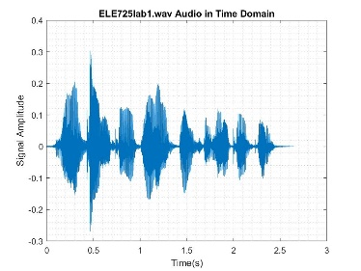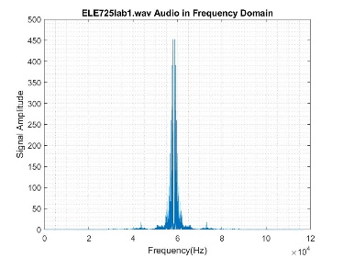

(a) (b)

Figure 1: (a): original Audio Signal in time domain. (b): original audio signal in frequency domain

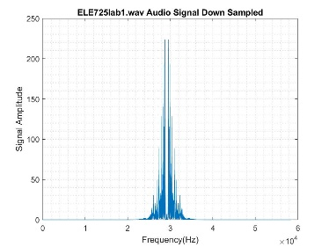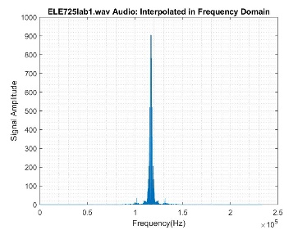

(a) (b)

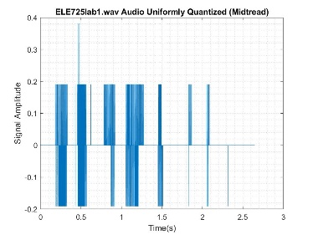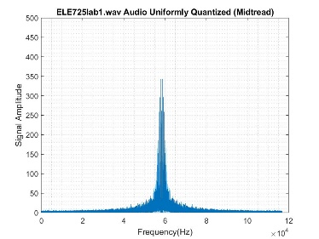

(c) (d)

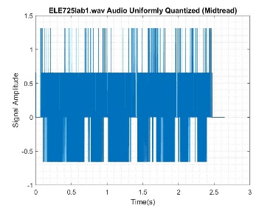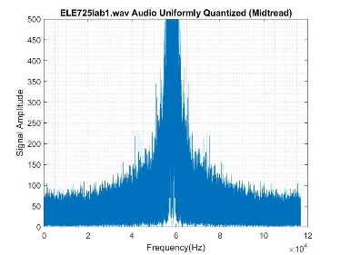

(e) (f)

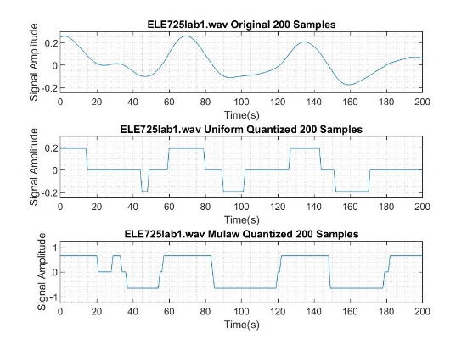

(g)

Figure 2: Audio signal plots for sampling factor of N=2. (a): down sampled signal in frequency domain. (b): up sampled signal in frequency domain. (c): quantized signal in time domain. (d): quantized signal in frequency domain. (e): mulaw quantized signal in time domain. (f) mulaw quantized signal in frequency domain. (g): 200 sample comparison of the original audio signal with the uniform and non-uniform quantization

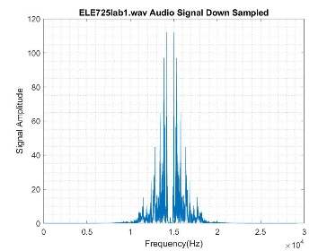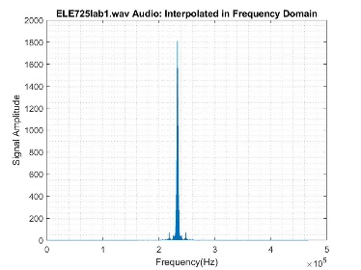

(a) (b)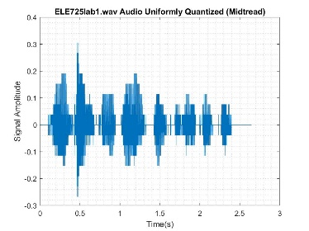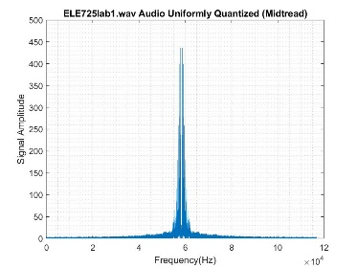

(c) (d)

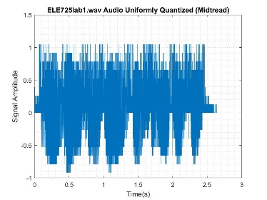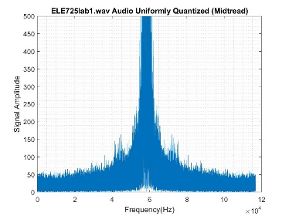

(e) (f)

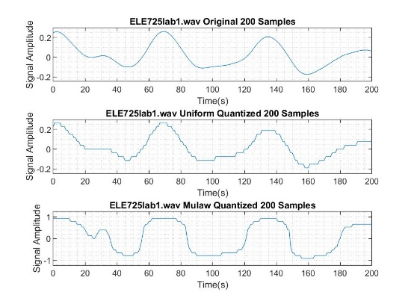

(g)

Figure 3: Audio signal plots for sampling factor of N=4. (a): down sampled signal in frequency domain. (b): up sampled signal in frequency domain. (c): quantized signal in time domain. (d): quantized signal in frequency domain. (e): mulaw quantized signal in time domain. (f) mulaw quantized signal in frequency domain. (g): 200 sample comparison of the original audio signal with the uniform and non-uniform quantization

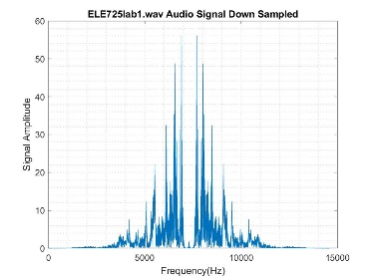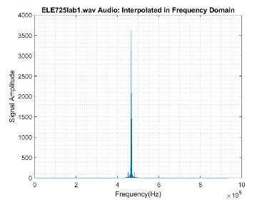

(a) (a) 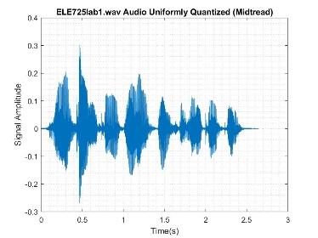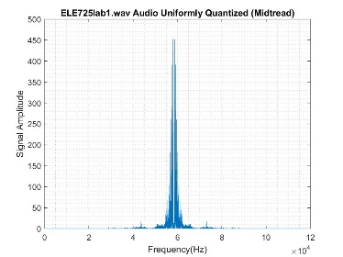(c) (d)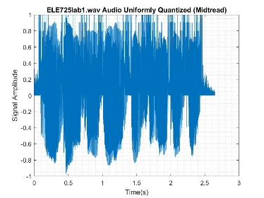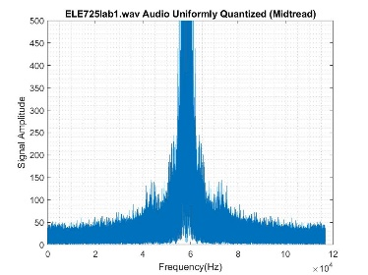

(e) (f)

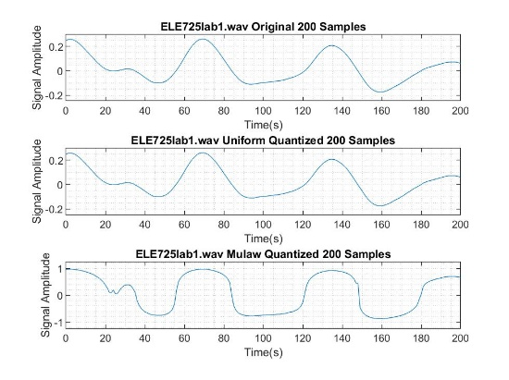

(g)

Figure 4: Audio signal plots for sampling factor of N=8. (a): down sampled signal in frequency domain. (b): up sampled signal in frequency domain. (c): quantized signal in time domain. (d): quantized signal in frequency domain. (e): mulaw quantized signal in time domain. (f) mulaw quantized signal in frequency domain. (g): 200 sample comparison of the original audio signal with the uniform and non-uniform quantization

# Discussion

## Sampling

Figure 2(a), 3(a), and 4(a), shows the down sampled signal with sampling factor N = 2, 4, 8 respectively. These plots have varying center frequency and signal amplitude seen in Table 1 that shows a direct relation with the sampling factor where the relationship is described as the following:

$$centre frequency =$$

$$\frac{centre fequency of orignal signal}{sampling factor \left(N\right)}$$

$$amplitude =$$

$$\frac{amplitude of orignal signal}{sampling factor \left(N\right)}$$

Similarly, Figure 2(b), 3(b), and 4(b), shows the up sampled signal with sampling factor N = 2, 4, 8 respectively. Its center frequencies and signal amplitude’s relation with the sampling factor can be described as the following:

$$centre frequency =$$

$$center fequency of orignal signal ×sampling factor (N)$$

$$amplitude =$$

$$amplitude of orignal signal ×sampling factor (N)$$

|  |  |  |  |
| --- | --- | --- | --- |
|  | Sampling Factor (N) | Approximate Center Frequency (Hz) | Approximate Signal Amplitude |
| (original) | 60 000 | 450 |
| Down Sampled | 2 | 30 000 | 225 |
| 4 | 15 000 | 112 |
| 8 | 7 500 | 56 |
| Up Sampled | 2 | 120 000 | 900 |
| 4 | 240 000 | 1 800 |
| 8 | 480 000 | 3 600 |

Table 1: approximate center frequencies and signal amplitude of down sample and up sampled plots.

The sound quality of the down sampled audio decreases as the sampling factor increases. The audio with N=8 sounded the most muffled. This is to be expected because down sampling removes some sample from the audio thus playback is not as clear. On the other hand, the sound quality of the up sampled audio did not show much significant difference from the original audio. This is an example of Weber’s law is due to the fact that no *significant* additional information is retrieved when up sampling the original audio which was of high quality to begin with.

# Conclusion

At the end of your report, you should comment on the main results and summarize the main findings in the laboratory. This can be short – one to two paragraphs in length only. Try to identify the important tradeoffs/themes encountered in the lab.

##### References

1. [1] Z. Li and M. Andrew, *Fundamentals of Multimedia*, 1st ed. New Jersey: Pearson Education, 2004.